Formatting with CSS

1. Cascading Style Sheets
2. Used for styling and formatting websites.
3. Html is used to create the content and CSS is for the design of the website.
4. 3: inline, internal and external.
5. Inline: by using the <style> tag inside HTML elements.

Internal: by using a <style element in the <head> section.

External: by using a <link> element to link an external CSS file.

1. External is the best way since then you have the most power over it.
2. A selector is the first part of a CSS rule, it is a pattern of elements and other term that tell the browser which html elements should be selected to have the CSS property values inside the rule applied to them.
3. A CSS declaration is am ordered collection of CSS properties and values.
4. Idfk you’re asking a fucking junior mate, it can probably be done in one h but idk man.
5. 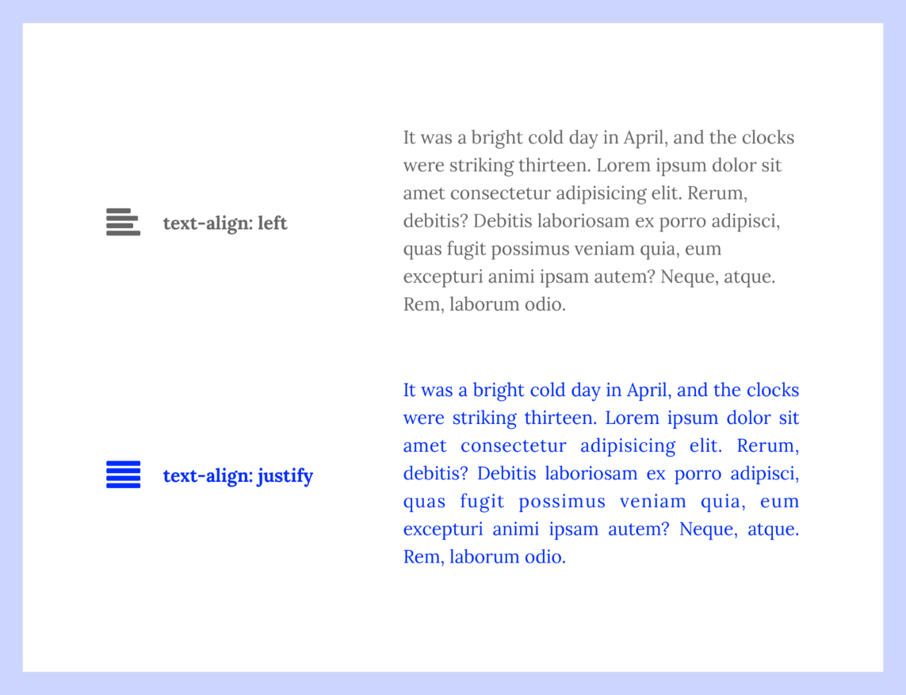
6. In CSS, a class is a group of elements that are the same or similar.
7. The id selector uses the id attribute of an HTML to select a specific element.
8. One is for specific tasks the other is for more common tasks
9. A margin is the space around an element’s border, while padding is the space between an element’s border and the element’s content
10. In CSS inheritance controls what happens when no value is specified for a property on an element
11. Inline elements only cover the space as bounded by the tags in the html element
12. It can be used as a container for html elements, you can easily style it by using the class or id attribute, you can put any sort of content in the tag